|  |  |
| --- | --- |
| Course Name | ITD 2313 – Script Programming |
| Instructor | Mark Pranger |
| Student Name | Josh Jones |
| Due date | May 26 |
| Grade | <grade earned here> |
| Grading Comments | <instructor comments here> |

Project 4:

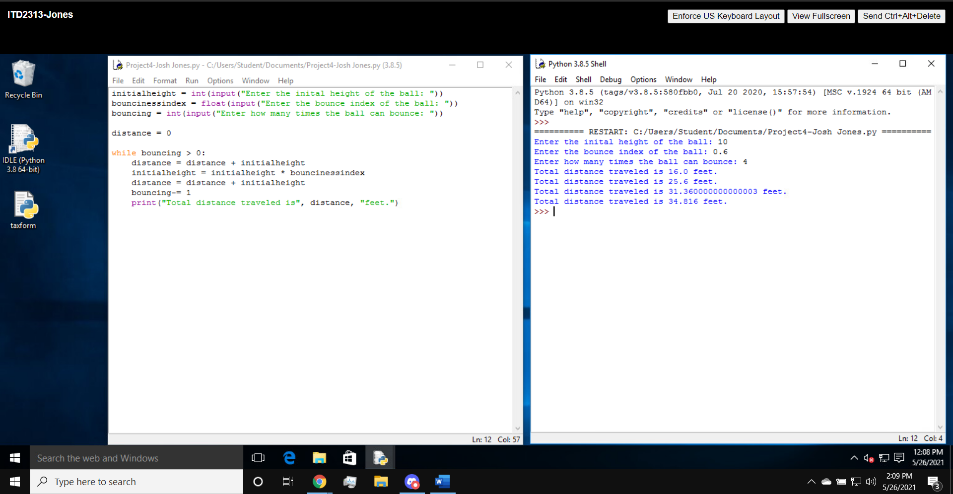

Project 5:

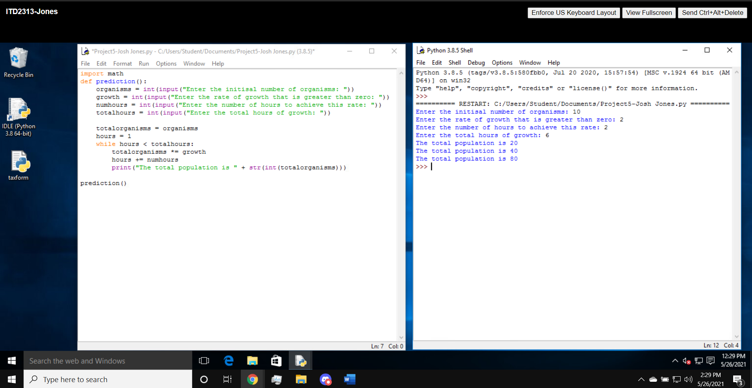

Project 6:

